CMOS Inverter

- Project Title : Design and analysis of CMOS inverter
- Name : J.Sunandha
- College : NBKR Institute of Science and Technology
- Department : Electronics and Communication Engg.
- Tool Used : LTSpice
- Date : 15 March 2025
Abstract :
This project presents the design and simulation of a CMOS inverter using LTspice. The voltage transfer characteristics, propagation delay, and power dissipation are analyzed. The results demonstrate the switching behavior and noise margins of CMOS logic circuits.
Introduction:
Background :
Integrating a large number of transistors (logic gates, memory) onto a single chip.
Design Flow:

Key Design Aspects:
Packing Density : Number of transistors per unit area (aiming to increase).
Power Dissipation : Lower power is critical for modern devices.
Speed : Clock frequency and performance.
Types : Full Custom (high performance), ASIC (Application
Specific Integrated Circuit), FPGA (Field ProgrammableGate Array).
Basics of CMOS Technology
Components: Uses both PMOS (P-channel) and NMOS (N-channel) transistors.
Structure:
Pull-Up Network (PUN): Consists of PMOS transistors (connected to VDD), providing a path to high voltage when needed.
Pull-Down Network (PDN): Consists of NMOS transistors (connected to GND), providing a path to low voltage.
Advantages: Very low power consumption (power is mainly consumed during switching, not at steady state).
CMOS Inverter (Fundamental Logic Building Block)
Operation: A PMOS at the top (pull-up) and an NMOS at the bottom (pull-down).
Input '0' (Low): NMOS is OFF, PMOS is ON. Output is pulled to
('1').
Input '1' (High): NMOS is ON, PMOS is OFF. Output is pulled to GND ('0').
Characteristics: High noise immunity, low static power dissipation.
Transistor Basics (NMOS/PMOS)
MOSFET: A three-terminal switch (Gate, Source, Drain).
NMOS: Conducts when the gate voltage is high (V_{gs} > V_{th}). Uses electrons as carriers.
PMOS: Conducts when the gate voltage is low (V_{gs} < V_{th}). Uses holes as carriers

Problem / Need :
The CMOS inverter is the fundamental building block of modern digital integrated circuits, essential for producing the NOT logic function (complementary output) with extremely low power consumption. Its core needs include providing high-density logic, high speed, high noise immunity, and full output voltage swings (0 to VDD) in processors, memory (SRAM), and digital systems.
Project Focus
I designed a CMOS inverter with PMOS and NMOS along with the voltage sources (Vin and VDD). For Vin I gave a pulse signal as follows
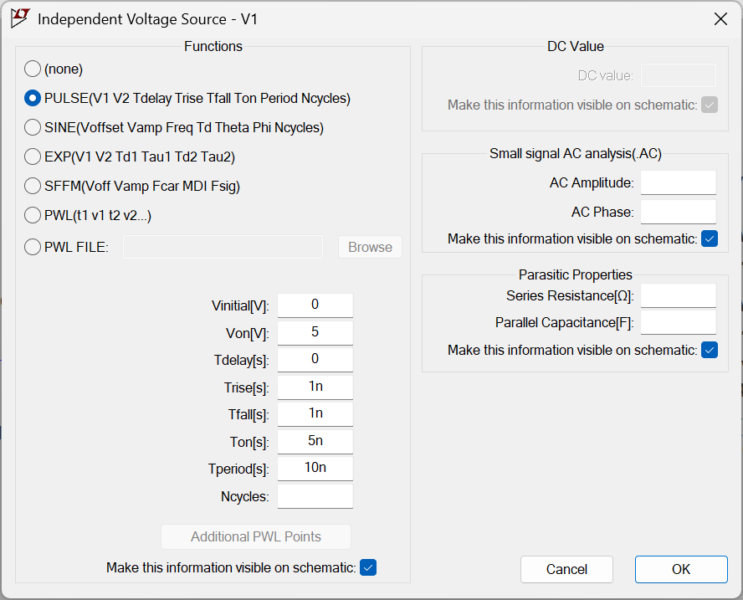

Circuit Design
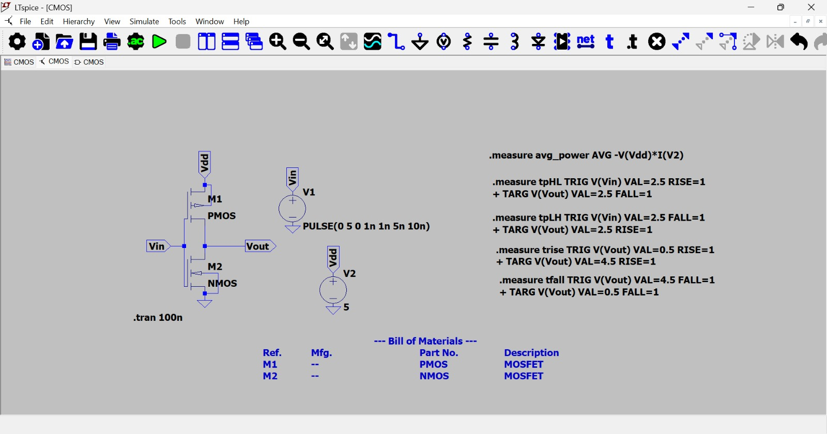
Simulation Setup

Results and Waveforms
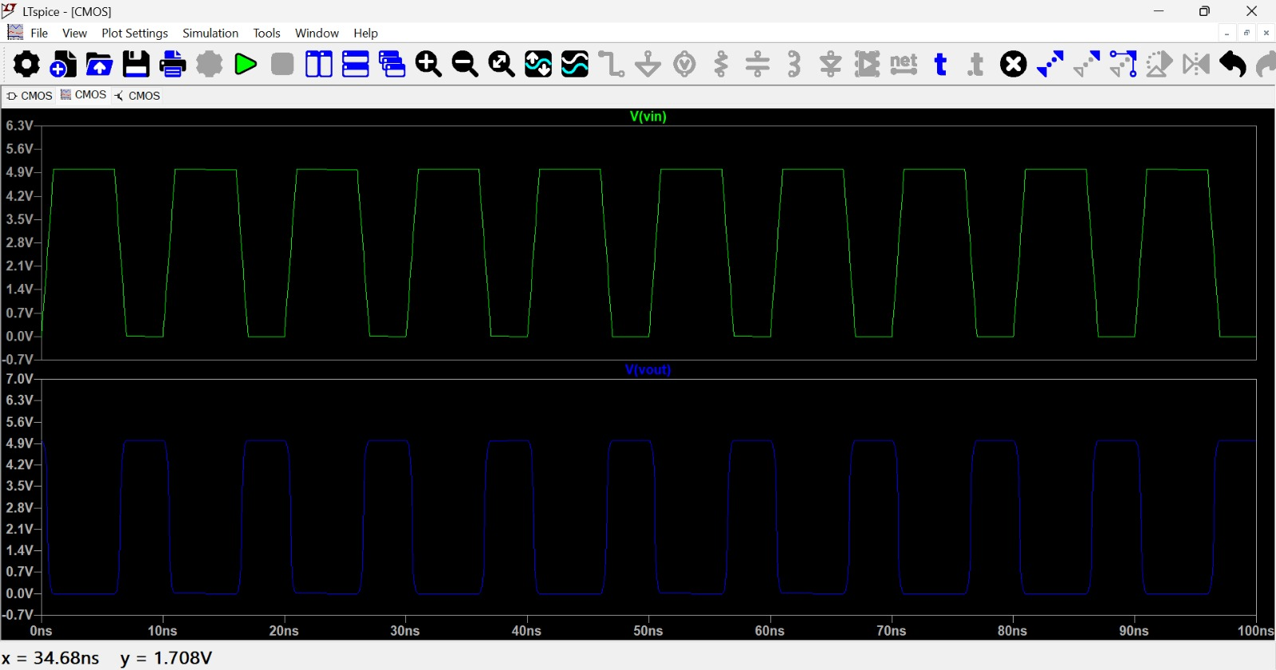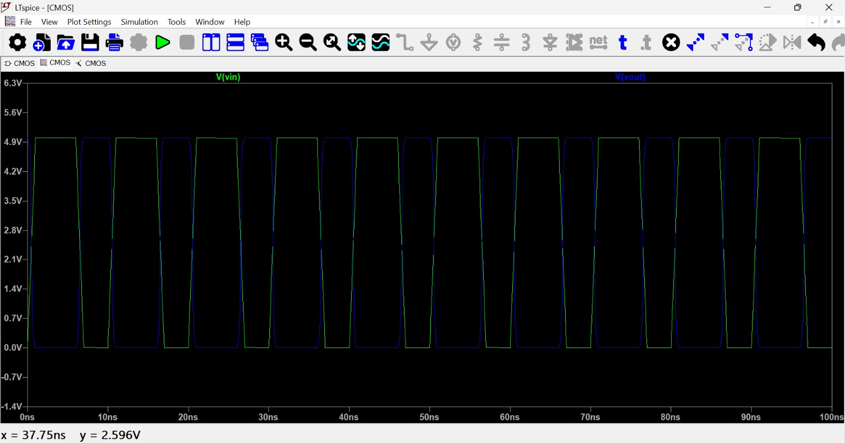
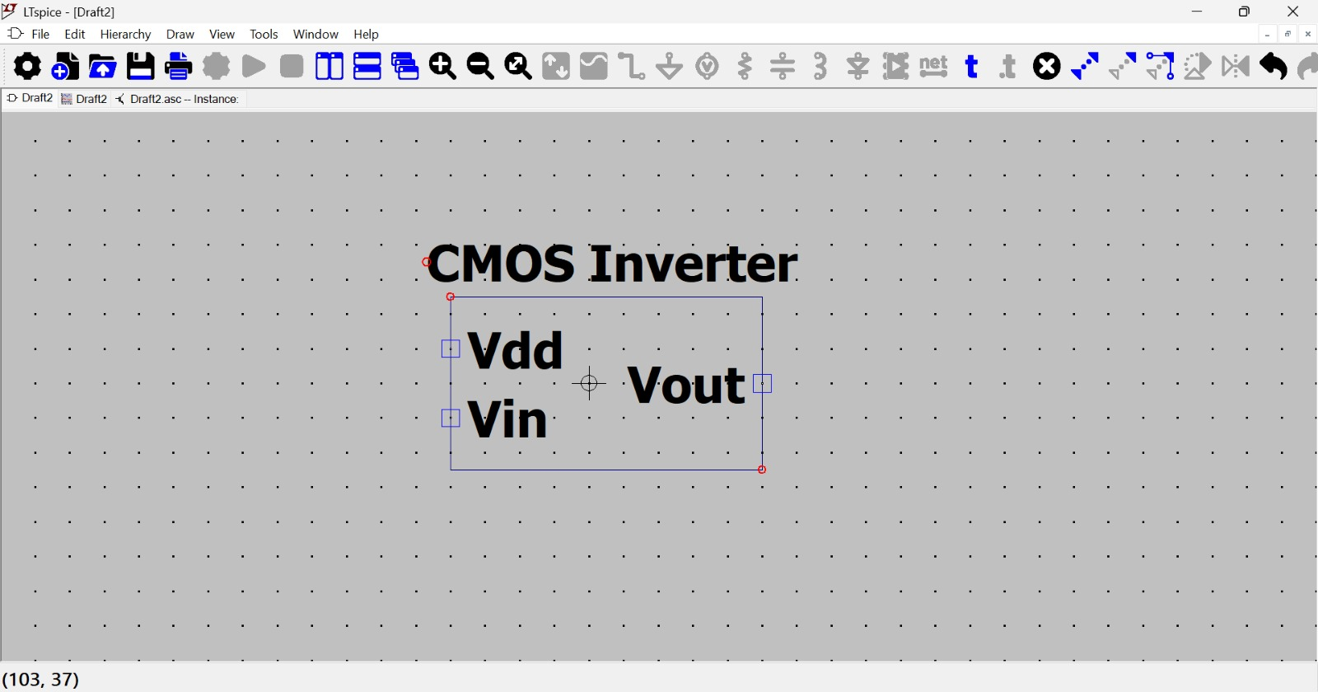

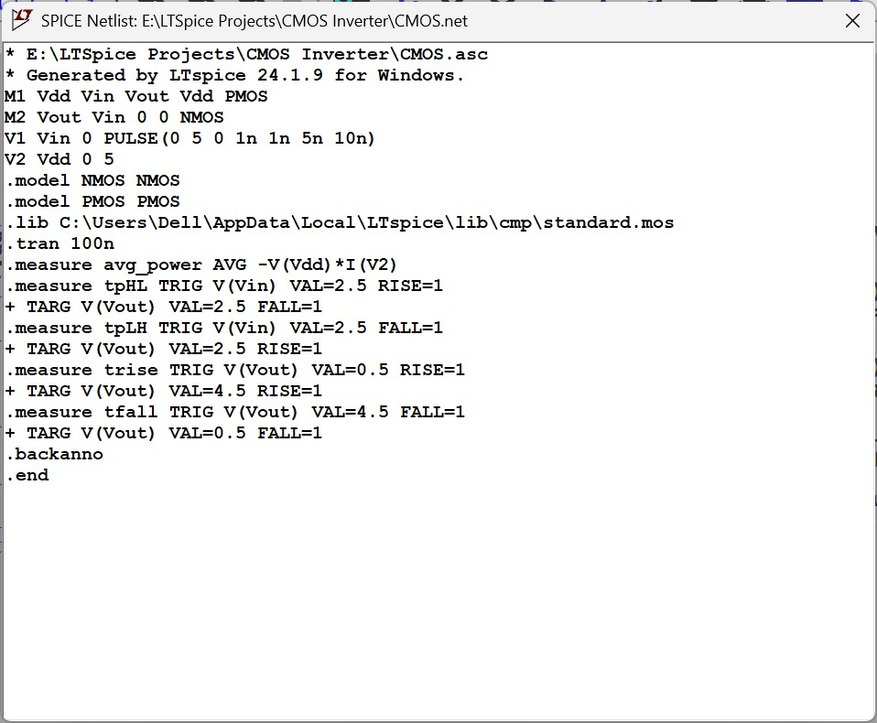

Performance Analysis
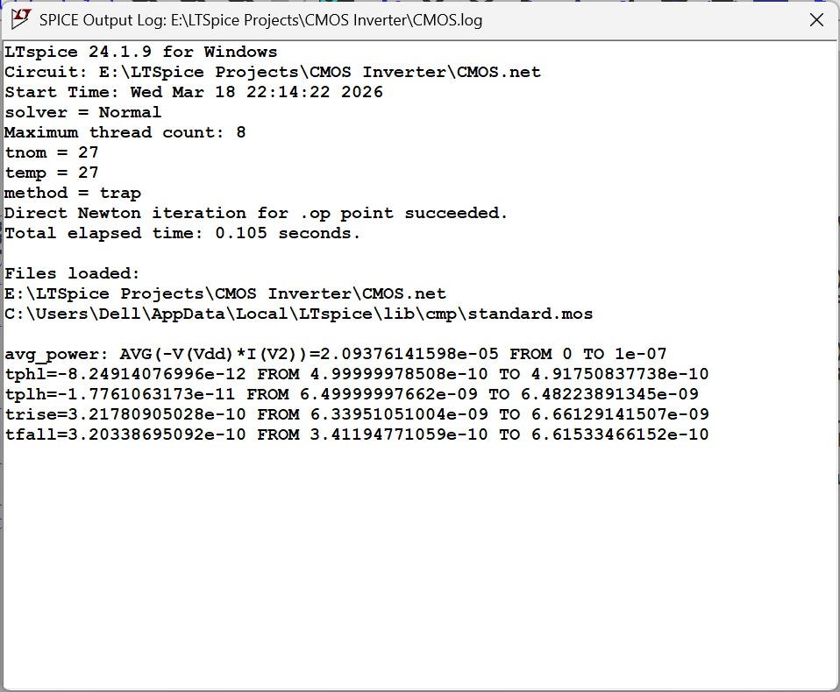
Parameter Value:
Propagation Delay : tpHL = 8.25 ps , tpLH = 17.76 ps
T_{p} =(8.25+17.76)/2 = 13.005 ps
Rise Time : 321 ps
Fall Time : 320 ps
Power Consumption : 20.9 µW

Applications
- Basic Building Block of Digital Circuits
This can be used in many of the logic gate designs and it acts as the foundation of Digital VLSI Design.
- Used in Microprocessors & Memory
Every Chip we see these days uses millions of inverters so this inverter can be seen in Microprocessors, CPUs, SRAM Cell, Registers.
- Signal Amplification / Restoration

This also ensure noise Immunity and converts weak signals to clean digital signals.
- Clock Buffers & Drivers
Actually used in clock distribution networks and helps to drive large large loads.
- Power-Efficient Circuits

Basically CMOS Inverters consume very low static power and only dynamic power while switching and this make the CMOS technology dominates the moderns electronics.

Conclusion
The CMOS inverter was successfully designed and simulated using LTspice. The circuit demonstrated correct switching behavior with clear inversion between input and output signals. The measured propagation delay was approximately 13 ps, indicating high-speed performance. The rise and fall times were found to be nearly equal, showing balanced switching characteristics. The average power consumption was around 20 µW, confirming the low-power advantage of CMOS technology.
The results highlight that CMOS inverters provide an excellent trade-off between speed and power, making them a fundamental building block in modern VLSI systems. The observed difference between tpLH and tpHL reflects the inherent mobility differences between PMOS and NMOS transistors, which can be optimized through proper transistor sizing.
Overall, this project validates the efficiency, reliability, and importance of CMOS inverter design in digital integrated circuits.

